
Consolata Missionaries
PORTUGAL & ITALY

Pilgrimage

September 11 to September 21, 2017
11 days /9 nights stay
Fatima 100th anniversary
Early booking Promotion!
Reserve your trip before April 1st, 2017,
and get a discount of
US $100 pp (based on double occupancy)
After April 1st, your trip cost will be at $3,650 pp

from $3,550 pp*

Join us to discover: Fatima – Lisbon – Rome – Assisi
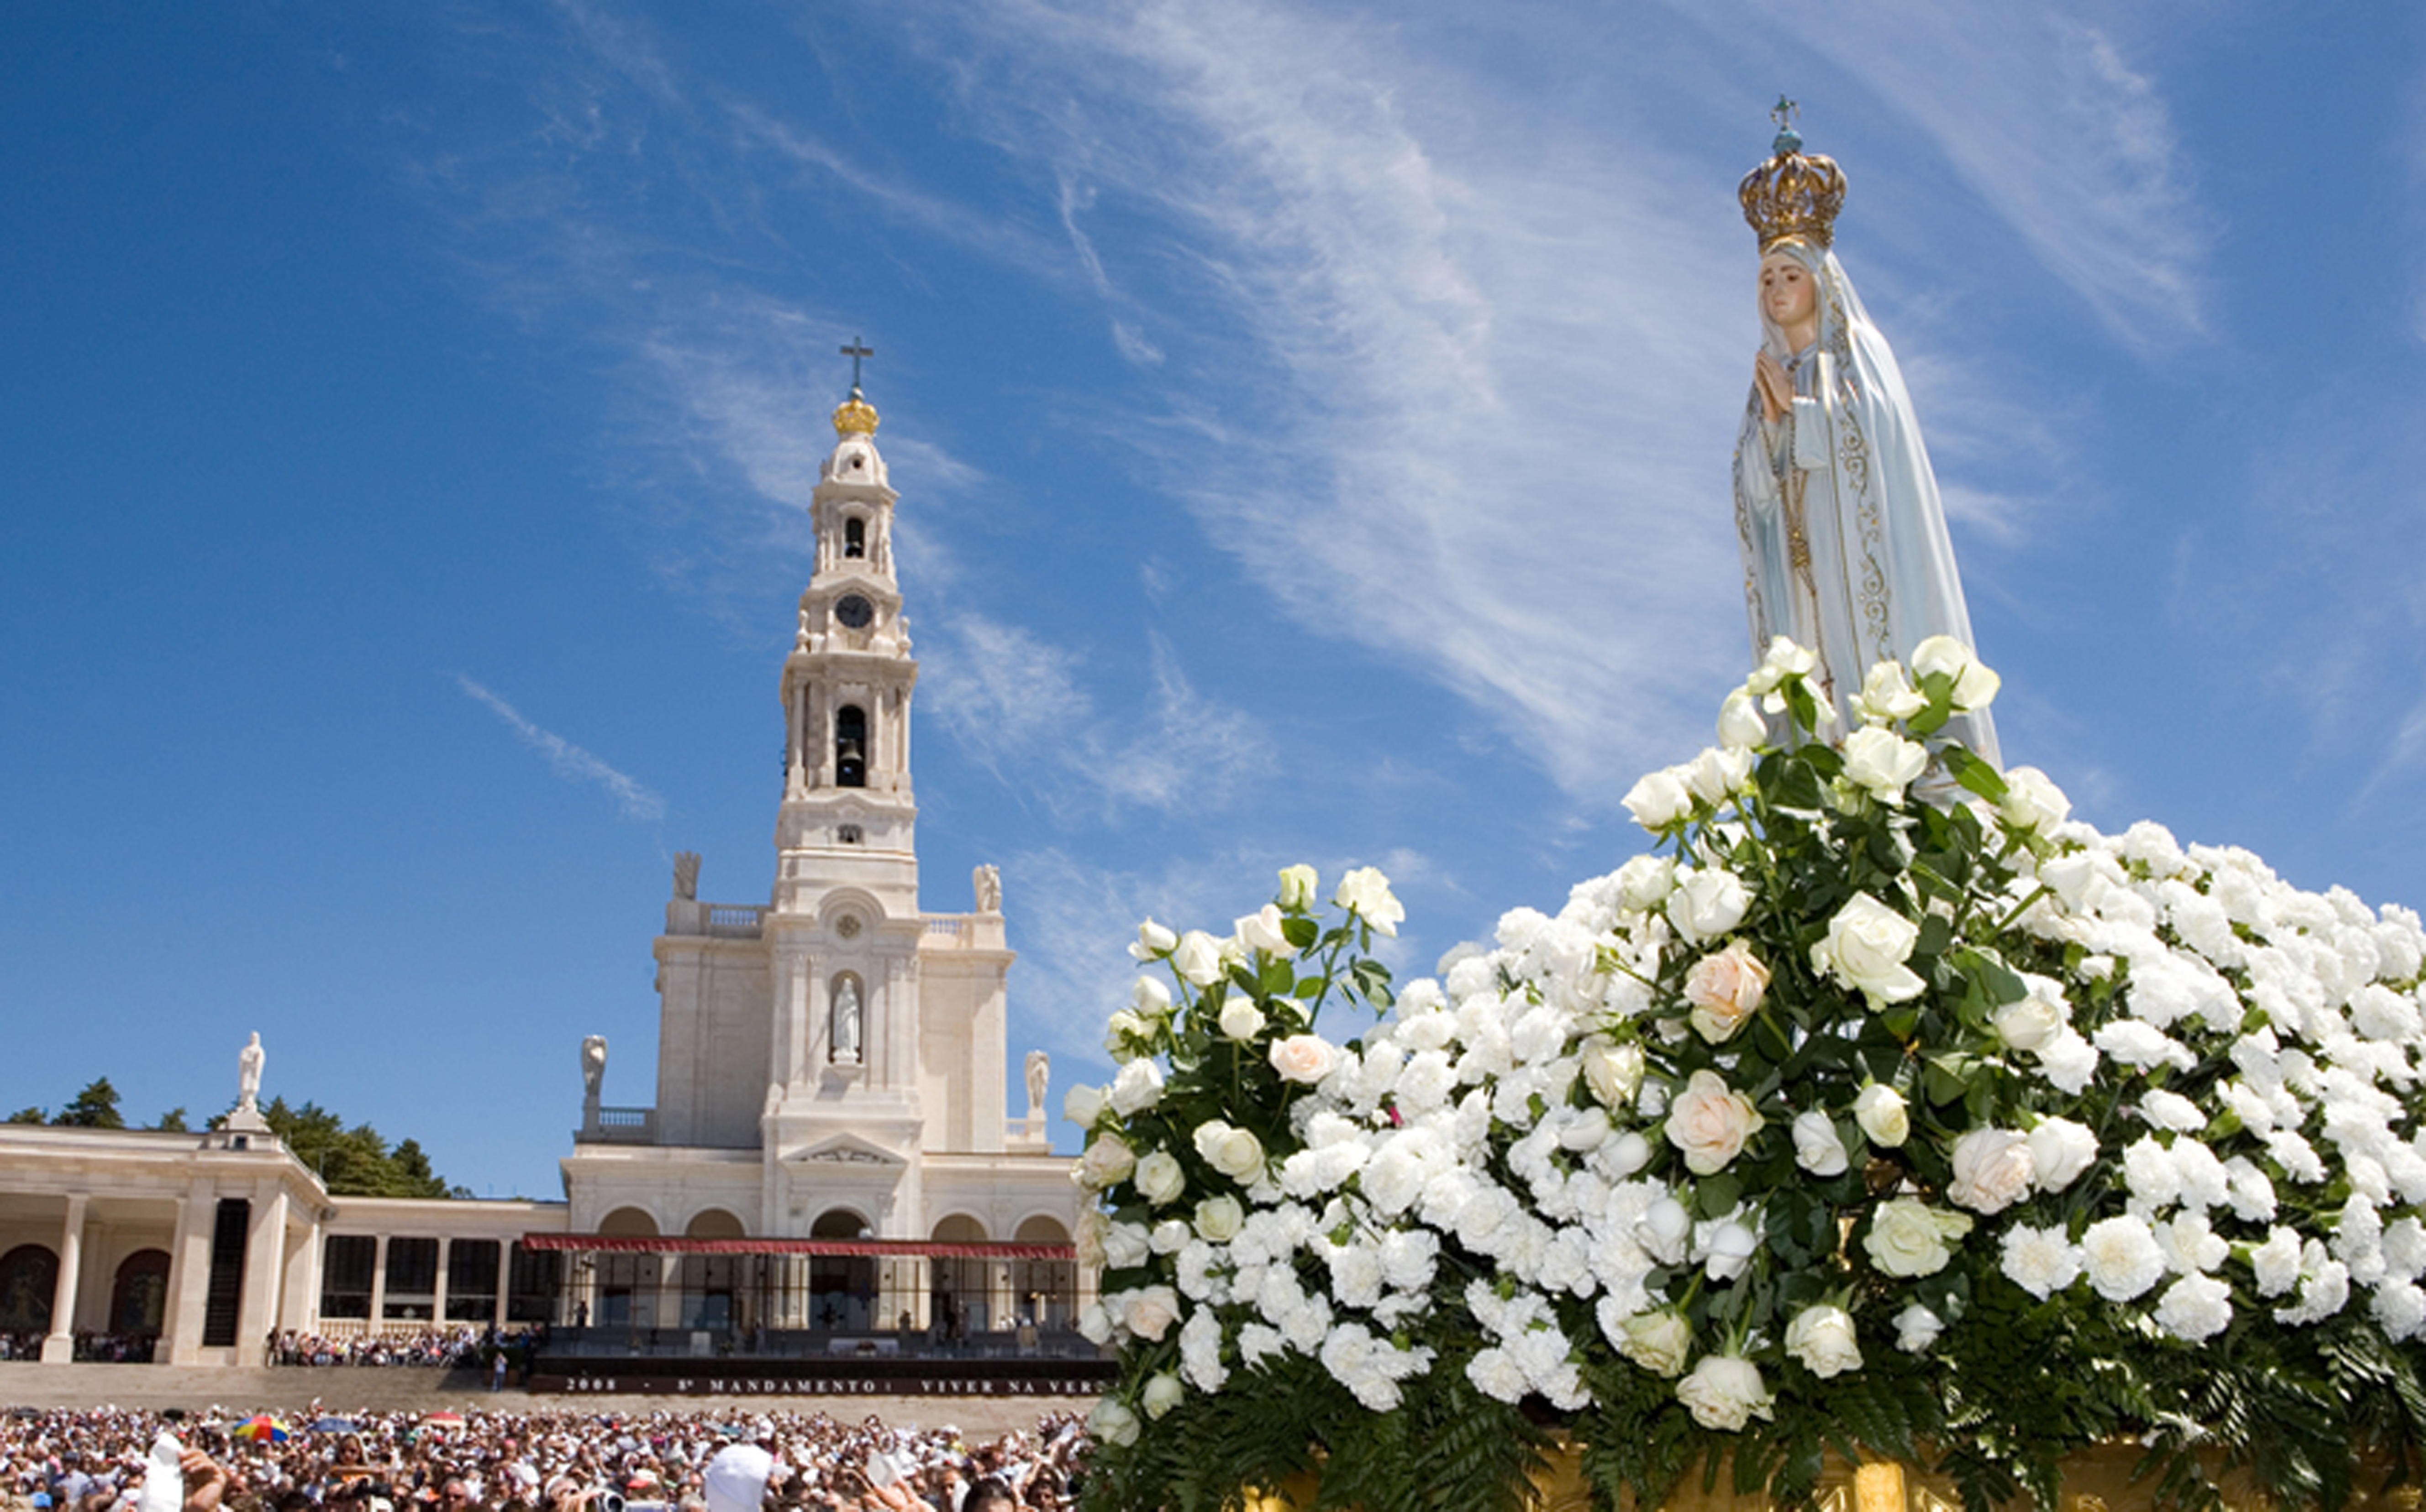
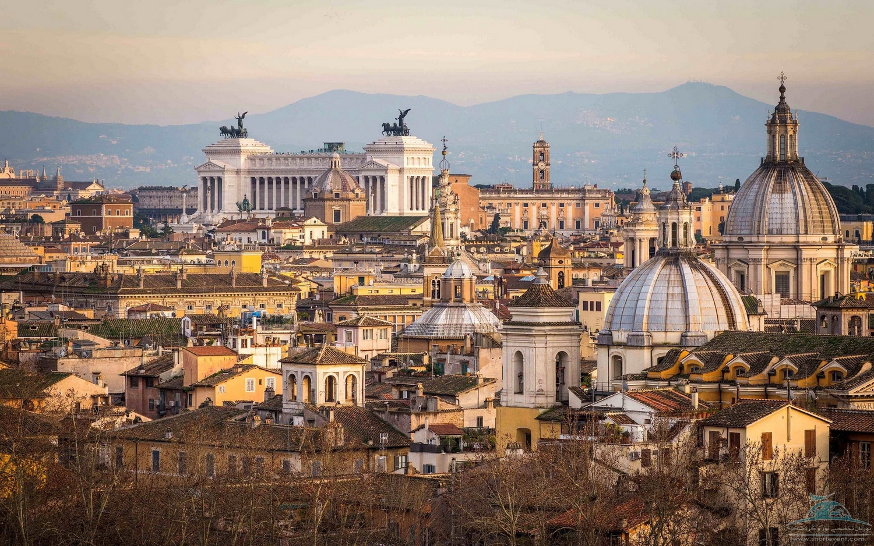
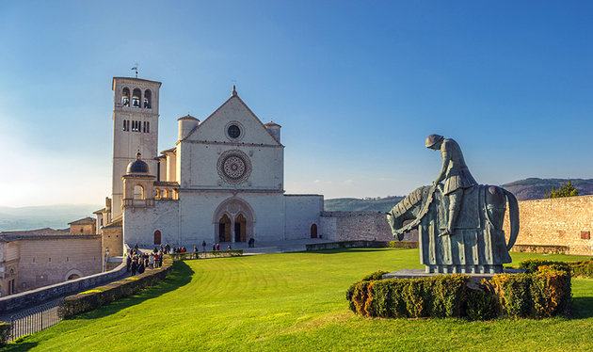

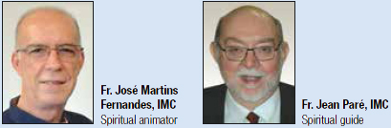
Travelers will be accompanied for the entire trip by Consolata missionaries, Father José Martins Fernandes spiritual animator
and Father Jean Paré spiritual guide.

- When in Fatima you will stay at the Consolata Hotel Pax, you will be assisting to a mass at the Esplanade, participation to a torchlight procession, visit of nearby villages and guided tour of Lisbon with narration by Father Jose
- In Rome, Papal audience, guided city tour, visit of great cathedrals, daily mass at Consolata headquarter chapel
- In Assisi, mass and guided tour with Father Jose and Jean.

During your stay you will discover and explore a few world heritage sites registered with UNESCO. Some of the sites visited have palyed an important role in the history of cathlocism
Pilgrimage offered with departures from New York (departure from Montreal or Toronto available on request)Including round-trip flight
One way flight from Lisbon to Rome
Deluxe Motor Coach transportation
Tour guide and tour leader
IMC Spiritual companions
9 nights 3 or 4-star Hotel accommodation (in double occupancy)
Meals: 10 breakfast + 6 lunch + 8 dinners (with wine) + 1 farewell dinner
Guided tours of cities and villages, as mentioned in itinerary and daily Eucharist celebration

*Certain conditions apply, based on availability at time of confirmation, for more information please read our detailed terms and conditions. Travel and cancelation insurance not included. Rates mentioned are in US $, unless otherwise specified. Special discounted rate can only be applied to bookings confirmed before April 1st, 2017, rates include taxes and fees. Rates are subject to change without prior notices. Reservation after April 1st, please add $100 per person (Dbl occupancy).
Itinerary

Day 1 Monday, September 11th, 2017
- Departure from New York (JFK)
- Departure from Toronto
- Departure from Montreal

Meeting at the airport with your tour leaders and guides. Overnight flight to Europe, destination Lisbon.

New York departure, direct flight to Lisbon.
Toronto departure, direct flight to Lisbon.
Note: for Montreal departures, going through Toronto and continuation with direct flight to Lisbon

Baggage allowance: 1 checked-in bag (20Kg max) + 1 carry-on

Day 2 Tuesday, September 12th, 2017 Lisbon - Fatima
Arrival at Lisbon International airport (morning)
Transfer to Fatima in deluxe Motor Coach
Arrival in Fatima, check-in and installation at Hotel Pax
Lunch at Hotel Pax
Free time to relax
Dinner at Hotel Pax
Evening torchlight procession
Mass on the Esplanade
Evening at leisure

Day 3 Wednesday September 13th, 2017 Fatima
Breakfast at Hotel Pax
Official beginning of pilgrimage with blessing of rosary candles
Eucharist celebration at the Esplanade Altar
Visit of the sanctuary
Lunch at Hotel Pax
Afternoon in Fatima (activities based on Fatima calendar)
Dinner at Hotel Pax
Evening torchlight procession

Day 4 Thursday, September 14th, 2017 Fatima - Lisbon
Breakfast at Hotel Pax
Transportation by deluxe Motor coach to Lisbon City Tour
Visit of the Hieronymites San Jeronimo Belem monastery
Tour of Belem
Lunch in famous Alfama neighborhood
Visit of Lisbon Cathedral (Sé Patriarcal)
Guided Tour of the City with a few stops
Return to Fatima
Dinner at Hotel Pax
Evening at leisure

Day 5 Friday, September 15th, 2017 Fatima – Batalha, Alcobaça, Nazare
Breakfast at Hotel Pax
Eucharist celebration at Hotel Pax Chapel
Transportation in deluxe Motor Coach for day of visit
Visit of Batalha, Alcobaça and Nazare
Lunch in Nazare
Free time in Nazare
Return to Fatima
Dinner at Hotel Pax
Evening at leisure

Day 6 – Saturday, September 16th, 2017 Fatima - Rome
Breakfast at Hotel Pax
Check-out and preparation of luggage
Transportation in deluxe Motor Coach from Fatima to Lisbon International Airport
Flight Lisbon to Rome (direct flight)
Arrival in Rome, transfer in deluxe Motor Coach to center of Rome
Lunch in downtown Rome (meal NOT included in package)
Guided City Tour with stops and explanations
Mid-afternoon, going to host Hotel
Check-in and installation
Free time to relax
Late afternoon, transfer to the Consolata Missionary Chapel
Eucharist celebration
Continuation to dinner in Rome
Return to host Hotel in the evening

Day 7 – Sunday, September 17th, 2017 Rome

Breakfast at the Hotel
Transportation in deluxe Motor Coach for day of visit
Guide Tour and visit of the major cathedrals of Rome, such as; Ste-Mary Majeure, St-John Latran and
a few others)
Lunch in Rome
Continuation of Cathedrals visit
Eucharist celebration at the Consolata Missionaries Chapel
Return to host Hotel
Free time to relax and preparation to go to dinner
Dinner in restaurant located close to Hotel

Day 8 – Monday, September 18th, 2017 Rome - Assisi
Breakfast at Hotel
Transportation in deluxe Motor Coach for day of visit
Eucharist celebration in Assisi
Lunch in Assisi
Continuation of Assisi’s visit (guided tour)
Dinner in a restaurant in a nearby village, on the way back to Rome.
Return to host Hotel in Rome

Day 9 – Tuesday, September 19th, 2017 Ancient Rome
Breakfast at Hotel
Transportation in deluxe Motor Coach for day of visit. Visit of Rome and historical sites; the Roman Forum, the Colosseum and the important monuments, Piazza di Spagna, Piazza Navonna and others, plus many other sites (please note that admission fees to visited sites, are NOT included in this package, unless otherwise specified)
Lunch in Rome (not included in package)
Free time in Rome for the rest of the afternoon
Transportation to the Eucharist celebration at the Consolata Missionaries Chapel
Return to host Hotel
Free time to relax and get ready for Dinner
Transportation in deluxe Motor Coach for Dinner in Trastevere, Rome famous neighborhood
Dinner in Trastevere
Night City Tour of Rome
Return to host Hotel

Day 10 – Wednesday, September 20th,2017 Rome and the Vatican
Breakfast at Hotel
Transportation in deluxe Motor Coach for the visit of the Vatican and Papal audience
Lunch in a restaurant near the Vatican (not included in package)
Vatican visit and/or visit of Saint Peter’s (admission fees NOT included)
Late afternoon return to host Hotel
Free time to relax and preparation to Dinner
Transportation in deluxe Motor Coach to Ostia
Farewell Dinner in Ostia
Return to host Hotel

Day 11 – Thursday, September 21st, 2017 - Rome – New York / Toronto / Montreal
Breakfast at Hotel
Check-out and preparation of your luggage
Transportation in deluxe Motor Coach from Hotel to Rome International Airport
Return flight to North America

End of trip

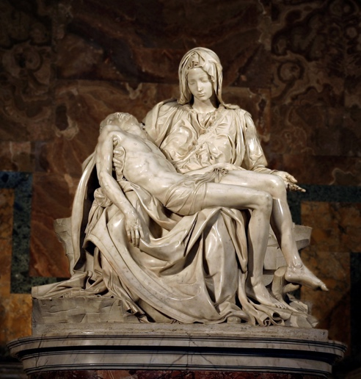
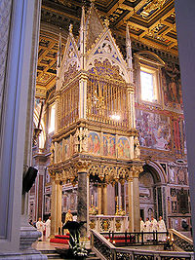
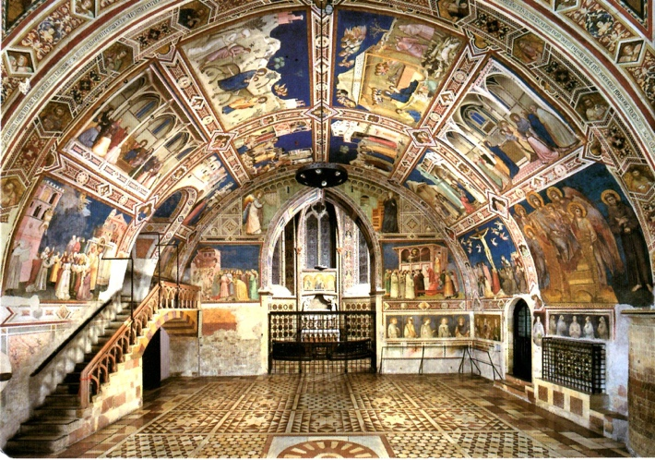

Consolata Missonaries * Pilgrimage Group: Portugal and Italy 2017

Dates: September 11th to September 21st, 2017
Duration: 11 days /9 nights

Departrues offered from: New York (JFK), Montréal or Toronto

Package includes: Round-trip flight

New York: flight from New York to Lisbon, flight from Lisbon to Rome, and return flight from Rome to New York
Toronto: flight from Toronto to Lisbon, flight from Lisbon to Rome, and return flight from Rome to Toronto Montreal: flight from Montreal to Toronto to Lisbon, flight from Lisbon to Rome, and return flight from Rome to Montreal.

All ground transportation in deluxe Motor Coach (50 seats) as per detailed itinerary
Visits and Tours (as described in detailed itinerary)
1 Guide and 1 Tour leader during the whole trip (multilingual assistance: English/ French/ Italian/ Portuguese)
1 spiritual animator and 1 spiritual guide (Consolata Missionaries)

9 nights Hotel stay – in 3 and 4-star category – in double occupancy (2 persons per room)

Meals:
10 breakfast Buffet style
6 Lunches
8 Dinners (with wine)
1 Farewell Dinner

Guided Tours with experienced, knowledgeable guided, with narration and explanation
Eucharist celebrations
Tips and gratuities to the Motor Coach drivers are included

1 Informative meeting preceeding your trip

- Travel, cancelation and medical insurance NOT included, may be purchased at time of confirmation. (Additional fees apply).

Consolata Missionaries * Pilgrimage Group: Portugal and Italy 2017
Early booking promotion
Confirm your trip before April 1st, 2017
And get a discount

Departures from United States (New York (JFK)):
US $3,550 per person (reservation and confirmation must be made before or at the latest April 1st, 2017)
US $3,650 per person (if trip confirm after April 1st, 2017)
(inclusive of taxes and minimum mandatory gratuities to the Motor Coach drivers- based on double occupancy per room (2 persons per room)

Based on a minimum of 45 participants – This package price is valid for departures from Toronto. For Single occupancy (1 person per room), please add US $950 to the above mentioned package price.
Stay extension may be available on request, pricing will be confirmed on a request basis and if airline allows.

Departrure from Montreal or Toronto your package price will be $3,999 CA (inclusive of all package
components as described in detailed itinerary – based on double occupancy (2 persons per room). For single
occupancy in room (1 person in room), please add $1,485 CA to the above mentioned package price.

Travel Insurance available on request, please contact us.

Consolata Missionaries * Pilgrimage Group: Portugal and Italy 2017
Terms and Conditions:
Deposit:
A deposit equivalent to US $500 per traveler, is required at time of confirmation. If you select to subscribe to the travel insurance, your full payment of the premium is required at time of confirmation, as well.
Payment:
The balance due will be due at least 60 days prior to your trip departure date, any delay in paying the balance due on your invoice will occur an automatic cancelation of your reservation and will be subject to our cancelation fees and penalties policy;

Cancelation fees:

Up to 60 days prior to your scheduled departure date: a penalty equivalent to US $500 per traveler will be applied.
Less then 60 days prior to scheduled departure date: no refund

Changes:
Based on the airline, a name change could be confirmed (if authorized by the airline), usually a fee of about US $300 will be applied. Please note that NO name change will be authorized if requested at 60 or less days prior to the scheduled travel dates. In that case, your reservation will simply be cancelled and no refund will be allowed.
The Consolata Missionaries and the agency, reserve the right to cancel the trip if the number of participants falls under the required number of 45, by the inscriprtion deadline or the travel dates could be changed for alternate date.
If the Consolata Missionaries decide to cancel the trip, you will be guaranteed a full refund of all collected money from you; this will represent your final and only settlement.
The Consolata Missionaries, the agency and their representatives, can not be held responsible or ask to intervene in a case where a traveler would experience any problems with the visited country authorities, or if a traveler is found guilty of non respect of the visited country laws and regulations.
Insurances:
We strongly suggest to the travelers to subscribe to a trip cancelation protection, in case of major problems such as death, severe illness, accident arising to yourself or a family member, or if the traveler should have to cancel the trip before departure or during the trip. We also suggest getting medical coverage. Please be informed, that insurance coverage is non refundable once paid for, it must be paid at time of confirmation of your trip. Travel cancelation protection can NOT be added later on, it must be purchased when confirming your participation to this trip.

Consolata Missionaries * Pilgrimage Group: Portugal and Italy 2017
Terms and Conditions: (next)
When purchasing the travel insurance coverage, please make sure to get all details as for the service included, guarantees, exclusions, limitations, insured risks and other important details on the coverage selected.

Claims:
You must inform your representative as soon as you experience any problems and may have to file a claim. When traveling abroad, you will be requested to inform your guide or tour leader or the host Hotel management, immediately, when experincing any problems or if in an emergency situation.
Pricing:
All mentioned prices are expressed in US dollars, unless otherwise specified for trips originating from United
States (New York) ; they are expressed in Canadian’s dollars for all departures from Montreal and Toronto.
Prices are subject to change up to 30 days prior to the departure date. Prices would only be revised ; if the fuel
price increases and the airline applies a surcharge, this surcharge would be applied towards the travelers
package price, or if the exchange rate increases of over 5% since the package promotion published date. If the
package price exceeds 7% of the original price, the travelers will be allowed to get a full refund of all money
paid.
The Consolata Missionaries and TICO Tours can NOT be held responsible of any acts, omissions, errors, loss,
damages or accident happening during the trip, nor can they be held responsible for any delay or cancelation of
any transportation service (including airline and ground transportation). The Consolata Missionaries and TICO Tours can NOT be held responsible for any traveler’s health issues, illnesses, injuries, losses or anxiety.

Reservation
Portugal & Italy 2017 Pilgrimage - From September 11th to 21st, 2017

___________________________________________ _________________________________________________________
Name & Surname *Note: as indicated in your passport

_____________________________________________________________________________________________________
Address

City Zip code Province/State
__________________________ _____________________ ________________________________
Tel: Work or cell #: Other:

Date of birth: _________________________ Emaill:__________________________________________________
mm/dd/ yyyy
Accommodation, room occupancy:

Single occupancy: add US $950 for New York
Double occupancy: Please indicate the name of your travel companion
_____________________________________________________________________________________________
If you do not have a travel companion, you request to be combined to an other traveler of same sex and share accommodations during this trip.

Personal & medical informations:
In case of an emergency during your trip, please indicate the name and contact information of the person you wish us to reach:
________________________________________________________ Tel: _______________________________
Name & surname

Do you have any allergies or food restrictions: _____________________________________________________

Do you have any physical restrictions (problems to walk or orthers) which may limit your participation to the activities and visits? ____ Yes ______ No
If you answered YES, please inform us of your physical condition and restrictions and of your special needs. Please be informed that the trip organizers reserve the right to refuse a participant which would not be sufficiently autonomous and not judged able to follow the rest of the group and would not be traveling with a dedicated companion.

Client Initials
If you experience certain restrictions which still allows you to participate and follow the rest of the group, and if you know you may need assistance, you must have a travel companion which is willing to assist you at all time during the trip. Please confirm the name and contact information of your travel companion.

Travel and cancelation insurance not included. Rate of US $3,550 is a discounted rate and can only be applied to bookings confirmed before April 1st, 2017, rates include taxes and fees. For bookings made after April 1st 2017, add US $100 (based on double occupancy)

Reservation (next…)
Portugal & Italy 2017 Consolata Missionaries Pilgrimage –
from September 11th to 21st, 2017

Please indicate your medical conditions: _____________________________________________________

_______________________________________________________________________________________
Is there any other information you think we should be aware of, so that we can make sure you will have the most memorable time and experience with us? ________________________________________________________________________________________
By signing this reservation form, I confirm I am aware of all terms and conditions and accept them entirely. I wish to confirm my participation to this trip and accept to pay the package price as mentioned below.
_______________________________________________ _________________, 2017
Signature Date
Package price: $_____________________

Deposit: $__________________ paid by: check credit card (Visa, Master Card)
The minimum deposit required at time of confirmation is $500 per person – the balance will be payable at the latest by July 13, 2017.

US travelers – Basic Plan (Please contact us for details)
Prices are indicated per pers. depending on age. | Departing from New York | With full knowledge of the facts, I decline, on my behalf and on behalf of the persons appearing on my file, the travel insurance offer proposed by the travel advisor.  I release the travel agency from any liability for any loss that may result from my refusal.
25 to 34 | - 122 $
35 to *60 | - 135 $
*61 to 70 | - 205 $
*71 to 75 | - 295 $
*75 to 78 | - 355 $
*80 and up | - Call for quote
*After age 60 traveler’s prices may change. Below prices may serve as GUIDE only
Pricing per person, must be bought at time of trip purchase or at the latest 4 days after confirming trip. Pricing may change without prior notice; coverage is subject to insurance company’s approval

*For credit card payment, please contact us.

